**REPORT ON PHARMACETICAL COMPANY DATABASE**

PREPARED AND SUBMITTED BY

**Pravesh Bisaria(2017Btechcse107)**

**Viral Natani(2017Btechcse307)**

**Hitika Ailani(2017Btechcse212)**

**Yashi Saini(2017Btechcse221)**

FACULTY GUIDE

**Dr. Alok Kumar**



**Department of Computer Science**

**Institute of Engineering and Technology (IET)**

**JK Lakshmipat University, Jaipur**

**April 2019**

INDEX

1. Client Functional Requirements

2. Improved Functional Requirements

1. ER Diagram
2. Relational Model
3. Database Schema
4. Normalised Tables
5. Database Dictionary
6. Sample Records
7. SQL Queries
8. JAVA Front End

**Client Functional Requirements**

1. Firstly, it will carry basic information about a medicine i.e. its name, description and particular I’d which will be unique.
2. Secondly it will be classified according to their categories which will carry information about the type of disease they are, I’d, colour, for which age group the medicine is recommended.

1. Then it will carry the whole stock data in which information spread will be telling you about the date manufactured the date it was sold, quantity we persist, to be sold on a particular date, quantity after selling medicine on a particular date and the cost of that medicine.
2. Then we want the names to which we sold our medicines it can be other companies, retail shops or to direct customers.
3. The medicines which we import from other (companies). The companies can be in foreign too, so the table will also contain the price at which we purchased, the amount of gst applied and various other taxes.
4. There will be info about the raw materials which are required to make medicines, there quantity, the amount in which that particular quantity is purchased and the left-over quantity which is to be purchased further to complete the whole purchasing of that particular raw material.

**Improved Functional Requirements**

1. Information about medicine which will include unique id for each product, its name, generic name and disease it cures.

2. Production is divided with respect to batch number and batch number is assigned to different lot of same medicine which are manufactured on different dates.

3. Also each lot of medicine is developed from different batches of raw material.

4. Finished products are kept in warehouse and termed as inventory.

5. Inventory is further divided into raw material inventory, manufactured inventory and purchased medicine inventory.

6. Manufactured inventory keeps record of products ready for sale and are identified according to their batch number which is assigned at the time of production.

7. Manufactured inventory contains information about batches of medicine which include their acquisition date, expiry date, quantity initially acquired, quantity left and medicine ID.

8. Purchased inventory keeps the record for medicines which are bought from other companies and are identified with respect to batch number which are assigned at the time of purchase.

9. Purchased inventory contains information about batches of medicine which include their acquisition date, expiry date, quantity initially acquired, quantity left, medicine ID and seller ID.

10. Inventory for raw material include raw material divided with respect to batches and raw material ID, their acquisition date, expiry date, initial quantity, quantity left.

11. Invoice is generated for every order which includes unique invoice ID, generation date, contents, quantity, buyer ID, tax applied, discount given, total amount to be paid.

12. To buy goods by the firm, purchase orders are used.

13. Purchase order are made up of Unique purchase order ID, its generation date, contents, their quantity, seller ID, tax applied, discount given, and amount to pay.

14. A separate record of sales is maintained which contains record of different products with their selling date, their batch number, buyer ID and quantity sold.

15. A separate record of Buyer and Supplier Companies are kept which contains unique buyer and seller ID, their email Id, phone number and medicines which are bought or supplied respectively.

**ER Diagram**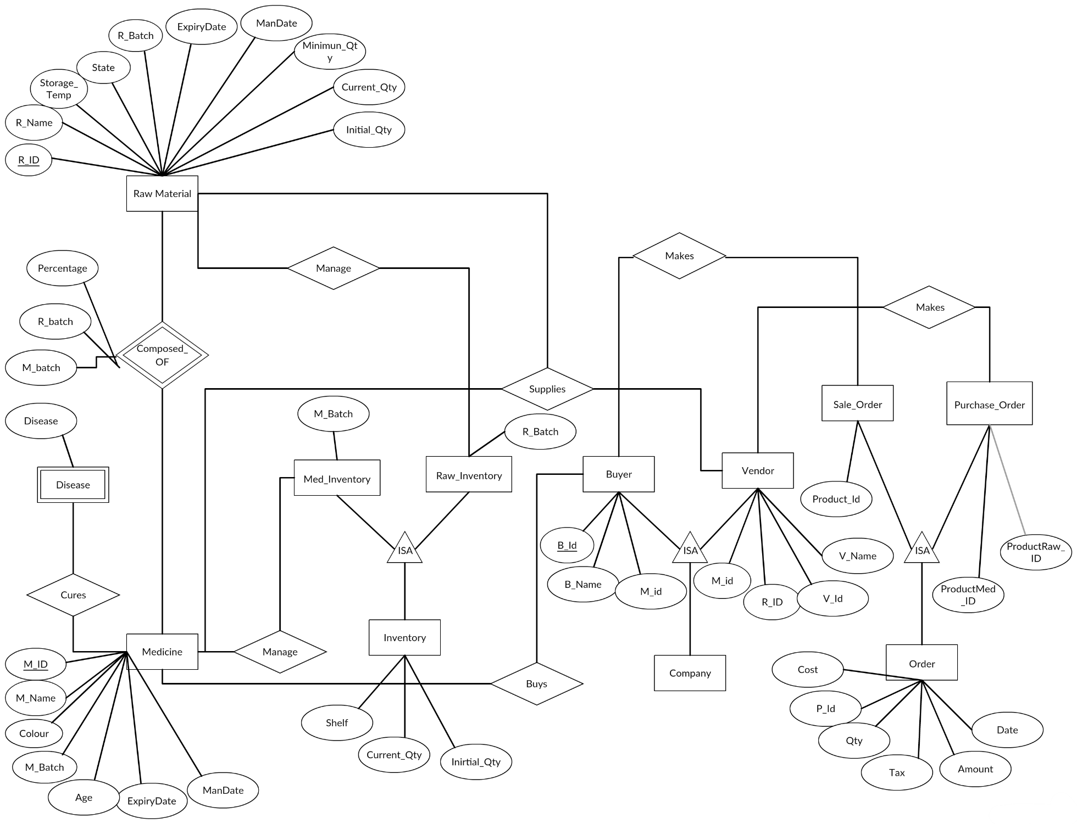

**Relational Model**

1. Medicine – (M_Id, M_name, M_batch, Expirydate, ManDate, Colour, Age)
2. Disease –(Disease, M_id)
3. Composition –(M_Id, R_Id,Percentage, M_batch, R_batch )
4. Raw_Material –(R_Id, R_name, Storage_temp,State R_batch, ExpiryDate,ManDate, Minimum_Qty, Initial_Qty, Curreny_Qty)
5. Buyer –(B_Id, B_name , M_Id )
6. Vendor –(V_Id,V_name ,M_Id,R_Id )
7. Raw_Inventory –(R_batch, R_Id, Shelf , Initial_Qty, Current_Qty )
8. MedInventory --(M_batch, M_Id, Shelf, Initial_Qty,Curreny_Qty )
9. Purchase_Order –(P_Id, ProductMed_Id, ProductRaw_Id Qty , Cost, date, V_Id, Tax, Amount , Discount, Mode)
10. SaleOrder –(P_Id, Product_Id , Qty, Cost, date, B_Id, Tax, Amount , Discount, Mode)

**Database Schema**

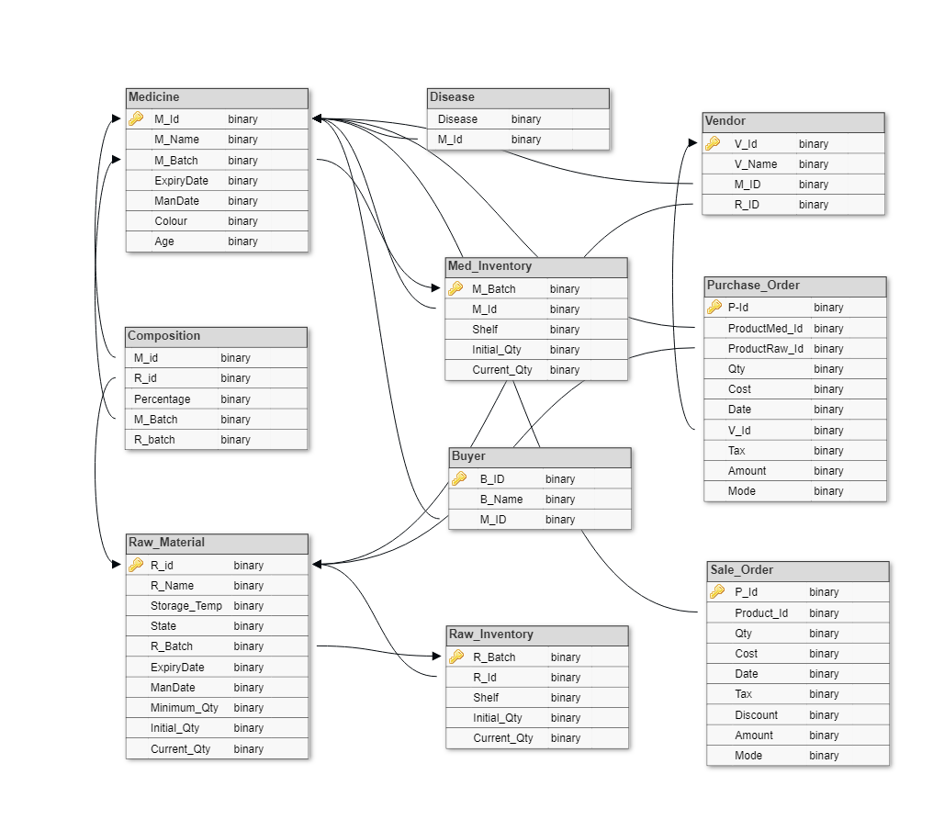

**Normalised Tables**

**1.Medicine:**

* + - * Medicine_Info {M_Id, M_name,Color,Storage_Temp,Age}
      * Disease {Disease, M_Id}
      * Medicine_Batch- {M_batch, M_Id, Expirydate, ManDate}

**2.Composition:**

* + - * Composition- {M_Id, R_Id,Percentage}
      * Batch_composition- {M_batch, R_batch}

**3.Raw_Material:**

* + - * Raw_Material {R_Id, R_name,Storage_Temp,State}
      * Raw_Batch {R_batch, R_Id, R_ExpiryDate, Minimun_Qty, Initial_Qty,Curreny_Qty}

**4.Company:**

* + - * Buyer_MedCompany {BM_Id,BM_name , M_Id }
      * Vendor_MedCompany {VM_Id,VM_name M_Id }
      * Vendor_RawCompany {VR_Id, VR_name,R_Id }

**5.Inventory:**

* + - * Raw_Inventory {R_batch, R_Id, Shelf , Initial_Qty,Curreny_Qty}
      * Manu_MedInventory {M_batch, M_Id, Shelf, Initial_Qty,Curreny_Qty}
      * Pur_MedInventory {M_batch, M_Id, Shelf, Initial_Qty,Curreny_Qty}

**6.Payment:**

* + - * SaleOrder {S_Id, date, C_Id, Tax, Amount , Discount, Mode}
      * M_PurOrder {P_Id, date, C_Id, Tax, Amount , Discount, Mode}
      * R_PurContent {S_Id, VR_PId, R_Qty, Cost}
      * M_SaleContent {S_Id, ,BM_PId M_Qty, Cost}
      * M_PurContent {P_Id,VM_PId, M_batch, M_Qty, Cost}

**Database Dictionary**

1. Table Name: Medicine_Info

Purpose: Information related each Medicine

|  |  |  |  |  |  |  |
| --- | --- | --- | --- | --- | --- | --- |
| Attribute  Name | Data  Type | Size | Key  Constraints | Null  /Not Null | Other  Constraints | Description |
| M_ID | Varchar | 20 | Primary Key | Not Null | - | Unique ID of each medicine |
| M_Name | Varchar | 30 | - | Not Null | - | Name of each medicine |
| Age | Varchar | 10 | - | Not Null | - | Medicine prescribed for particular age group |
| Storage_  Temp | Number | 4 |  | Not Null |  | Temperature suitable for keeping medicine |
| Colour | Varchar | 10 | - | Not Null | - | Colour of a medicine |

2.Table Name: Composition

Purpose: Composition of a Medicine

|  |  |  |  |  |  |  |
| --- | --- | --- | --- | --- | --- | --- |
| Attribute  Name | Data  Type | Size | Key  Constraints | Null  /Not Null | Other  Constraints | Description |
| M_ID | Varchar | 20 | Primary Key/  Foreign Key | Not Null | - | Unique ID of each medicine |
| R_ID | Varchar | 20 | Primary Key/  Foreign Key | Not Null | - | Unique ID of each raw material |
| Percentage | Number | 4 | - | Not Null | - | Percentage of chemical present in a medicine |

3. Table Name: Disease

Purpose: Medicine used in diseases

|  |  |  |  |  |  |  |
| --- | --- | --- | --- | --- | --- | --- |
| Attribute  Name | Data  Type | Size | Key  Constraints | Null  /Not Null | Other  Constraints | Description |
| M_ID | Varchar | 20 | Primary Key/  Foreign Key | Not Null | - | Unique ID of each medicine |
| Disease | Varchar | 20 | - | Not Null | - | Name of disease cured by a medicine |

4. Table Name: Medicine_Batch

Purpose: Information of Medicine Batch

|  |  |  |  |  |  |  |
| --- | --- | --- | --- | --- | --- | --- |
| Attribute  Name | Data  Type | Size | Key  Constraints | Null  /Not Null | Other  Constraints | Description |
| M_Batch_ | Varchar | 20 | Primary Key/  Foreign Key | Not Null | - | Unique ID of a medicine batch |
| M_ID | Varchar | 20 | Primary Key/  Foreign Key | Not Null | - | Unique ID of each medicine |
| R_Batch_  Code | Varchar | 20 | Primary Key/  Foreign Key | Not Null | - | Unique ID of a Raw Material batch |
| Manufactured_  Date | Date | - | - | Not Null | - | Manufacturing Date of a medicine |
| Expiry_Date | Date | - | - | Not Null | - | Expiry Date of a medicine |

5. Table Name: Batch_Composition

Purpose: Information of Medicine Batch Composition

|  |  |  |  |  |  |  |
| --- | --- | --- | --- | --- | --- | --- |
| Attribute  Name | Data  Type | Size | Key  Constraints | Null  /Not Null | Other  Constraints | Description |
| M_Batch_  Code | Varchar | 20 | Primary Key/  Foreign Key | Not Null | - | Unique ID of a medicine batch |
| R_Batch_  Code | Varchar | 20 | Primary Key/  Foreign Key | Not Null | - | Unique ID of a Raw Material batch |

6.Table Name: Med_Inventory

Purpose: Information related Medicine Stock

|  |  |  |  |  |  |  |
| --- | --- | --- | --- | --- | --- | --- |
| Attribute  Name | Data  Type | Size | Key  Constraints | Null  /Not Null | Other  Constraints | Description |
| M_Batch_ | Varchar | 20 | Primary Key | Not Null |  | Unique ID of a medicine batch |
| M_ID | Varchar | 20 | Primary Key/  Foreign Key | Not Null | - | Unique ID of each medicine |
| Shelf | Number | 10 | - | Not Null | - | Shelf no. in which medicine is placed |
| Initial_Qty | Number | 10 | - | Not_Null | - | Initial Quantity of a medicine in stock |
| Current_Qty | Number | 10 | - | Not Null | - | Current Quantity of a medicine in stock |

7. Table Name: Raw_Inventory

Purpose: Information related Raw Material Stock

|  |  |  |  |  |  |  |
| --- | --- | --- | --- | --- | --- | --- |
| Attribute  Name | Data  Type | Size | Key  Constraints | Null  /Not Null | Other  Constraints | Description |
| R_Batch_ | Varchar | 20 | Primary Key | Not Null |  | Unique ID of a medicine batch |
| R_ID | Varchar | 20 | Primary Key/  Foreign Key | Not Null | - | Unique ID of each raw material |
| Shelf | Number | 10 | - | Not Null | - | Shelf no. in which medicine is placed |
| Initial_Qty | Number | 10 | - | Not_Null | - | Initial Quantity of a medicine in stock |
| Current_Qty | Number | 10 | - | Not Null | - | Current Quantity of a medicine in stock |

8.Table Name: RawMaterial

Purpose: Information related Raw Materials

|  |  |  |  |  |  |  |
| --- | --- | --- | --- | --- | --- | --- |
| Attribute  Name | Data  Type | Size | Key  Constraints | Null  /Not Null | Other  Constraints | Description |
| R_ID | Varcahr | 20 | Primary Key | Not Null | - | Unique ID of each raw material |
| Name | Varchar | 30 | - | Not Null | - | Name of the Chemical |
| Storage_  Temp | Number | 4 | - | Not Null | - | Temperature suitable for a chemical |
| State | Char | 1 | - | Null | - | Atomic State of a Chemcial |

9.Table Name: Raw_Batch

Purpose: Information related Raw Material Batch

|  |  |  |  |  |  |  |
| --- | --- | --- | --- | --- | --- | --- |
| Attribute  Name | Data  Type | Size | Key  Constraints | Null  /Not Null | Other  Constraints | Description |
| R_Batch_  Code | Varchar | 20 | Primary Key | Not Null | - | Unique ID of a Raw Material batch |
| R_ID | Varchar | 20 | Primary Key/  Foreign Key | Not Null | - | Unique ID of each raw material |
| Minimun_  Qty | Number | 10 | - | Not Null | - | Minimum quantity of the Raw Material in stock |
| Initial_Qty | Number | 10 | - | Not Null | - | Initial quantity of the Raw Material in stock |
| Current_Qty | Number | 10 | - | Not Null | - | Current quantity of the Raw Material in stock |
| Expiry_Date | Date | - | - | Not Null | - | Expiry Date of a raw material batch |

10.Table Name: Buyer_MedCompany

Purpose: Information related buyer’s medicine company

|  |  |  |  |  |  |  |
| --- | --- | --- | --- | --- | --- | --- |
| Attribute  Name | Data  Type | Size | Key  Constraints | Null  /Not Null | Other  Constraints | Description |
| M_ID | Varchar | 20 | Primary Key | Not Null | - | Unique ID of each medicine |
| BM_Name | Varchar | 30 | - | Not Null | - | Name of medicine’s buyer |
| BM_ID | Varchar | 10 | - | Not Null | - | Unique ID of each buyer |

1. Table Name: Vendor_MedCompany

Purpose: Information of Vendor’s medicine company

|  |  |  |  |  |  |  |
| --- | --- | --- | --- | --- | --- | --- |
| Attribute  Name | Data  Type | Size | Key  Constraints | Null  /Not Null | Other  Constraints | Description |
| M_ID | Varchar | 20 | Primary Key/  Foreign Key | Not Null | - | Unique ID of each medicine |
| V_ID | Varchar | 20 | Primary Key/  Foreign Key | Not Null | - | Unique ID of Vendor |
| V_Name | Varchar | 30 | - | Not Null | - | Name of medicine’s vendor |

12.Table Name :Vendor_RawCompany

Purpose: Information of Vendor’s raw material company

|  |  |  |  |  |  |  |
| --- | --- | --- | --- | --- | --- | --- |
| Attribute  Name | Data  Type | Size | Key  Constraints | Null  /Not Null | Other  Constraints | Description |
| VR_ID | Varchar | 20 | Primary Key/  Foreign Key | Not Null | - | Unique ID of raw material vendor |
| VR_Name | Varchar | 20 | - | Not Null | - | Name of each raw material Vendor |
| R_ID | Varchar | 20 |  | Not Null | - | Unique ID of each Raw Material |

13.Table Name: SaleOrder

Purpose: Information of Medicine’s sale order

|  |  |  |  |  |  |  |
| --- | --- | --- | --- | --- | --- | --- |
| Attribute  Name | Data  Type | Size | Key  Constraints | Null  /Not Null | Other  Constraints | Description |
| S_ID | Varchar | 20 | Primary Key/  Foreign Key | Not Null | - | Unique ID of a sale order of medicine |
| C_ID | Varchar | 20 | Primary Key/  Foreign Key | Not Null | - | Unique ID of each customer |
| Date | Varchar | 20 | - | Not Null | - | Date on which order was placed |
| Tax | varchar | 10 | - | Not Null | - | Amount of tax added |
| Amount | varchar | 20 | - | Not Null | - | Total amount |
| Discount | Varchar | 10 | - | Null | - | Amount of discount provided |
| Mode | Varchar | 20 | - | Not Null | - | Mode of payment for order |

14.Table Name: M_PurOrder

Purpose: Information of Medicine Purchased

|  |  |  |  |  |  |  |
| --- | --- | --- | --- | --- | --- | --- |
| Attribute  Name | Data  Type | Size | Key  Constraints | Null  /Not Null | Other  Constraints | Description |
| P_Id | Varchar | 20 | Primary Key/  Foreign Key | Not Null | - | Unique ID of a payment batch |
| Date | Date | - |  | Not Null | - | Date of order |
| V_Id | Varchar | 20 | Primary Key/  Foreign Key | Not Null | - | Unique ID of a medicine vendor |
| Tax | Number | 20 | - | Not Null | - | Tax applied |
| Amount | Int | 20 | - | Not Null | - | Total price |
| Discount | Number | 20 | - | Not Null | - | Discount on Medicine |

15.Table Name: R_PurContent

Purpose: Information of Raw Medicine

|  |  |  |  |  |  |  |
| --- | --- | --- | --- | --- | --- | --- |
| Attribute  Name | Data  Type | Size | Key  Constraints | Null  /Not Null | Other  Constraints | Description |
| S_Id | Varchar | 20 | Primary Key/  Foreign Key | Not Null | - | Unique ID of a sale order of medicine |
| VR_PId | Varchar | 20 | Primary Key/  Foreign Key | Not Null | - | Unique ID raw material product |
| R_Qty | Number | 20 | - | Not Null | - | Quantity of raw material |
| Cost | Number | 20 | - | Not Null | - | Cost of raw material |

16.Table Name: M_SaleContent

Purpose: Information of Medicine Sold

|  |  |  |  |  |  |  |
| --- | --- | --- | --- | --- | --- | --- |
| Attribute  Name | Data  Type | Size | Key  Constraints | Null  /Not Null | Other  Constraints | Description |
| S_Id | Varchar | 20 | Primary Key/  Foreign Key | Not Null | - | Unique ID of a sale order of medicine |
| BM_PId | Varchar | 20 | Primary Key/  Foreign Key | Not Null | - | Unique ID of medicine product ID |
| M_Qty | Number | 20 | - | Not Null | - | Quantity of mediine |
| Cost | Number | 20 | - | Not Null | - | Costof mediine |

17.Table Name: M_PurContent

Purpose: Information of Medicine Content

|  |  |  |  |  |  |  |
| --- | --- | --- | --- | --- | --- | --- |
| Attribute  Name | Data  Type | Size | Key  Constraints | Null  /Not Null | Other  Constraints | Description |
| P_Id | Varchar | 20 | Primary Key/  Foreign Key | Not Null | - | Unique ID of payment |
| VM_PId | Varchar | 20 | Primary Key/  Foreign Key | Not Null | - | Vendor medicine product ID |
| M_batch | Varchar | 20 | Primary Key/  Foreign Key | Not Null | - | Batch Of Medicine |
| M_Qty | Number | 20 | - | Not Null | - | Quantity of medicine |
| Cost | Number | 20 | - | Not Null | - | Cost of medicine |

**Sample Records**

1. Table Name: Medicine_Info

|  |  |  |  |  |
| --- | --- | --- | --- | --- |
| M_ID | M_Name | Age | Storage_  Temp | Colour |
| M_001 | Crocin | 15 above | 25`C | White |
| M_002 | Meftal | 10above | 35`C | Yellow |

2.Table Name: Composition

|  |  |  |
| --- | --- | --- |
| M_ID | R_ID | Percentage |
| M_001 | R_010 | 80% |
| M_002 | R_110 | 25% |

3. Table Name: Disease

|  |  |
| --- | --- |
| M_ID | Disease |
| M_001 | Fever |
| M_002 | Pain Killer |

4. Table Name: Medicine_Batch

|  |  |  |  |  |
| --- | --- | --- | --- | --- |
| M_Batch_Code | M_ID | R_Batch_  Code | Manufactured_ Date | Expiry_Date |
| BD_901 | M_001 | RB_540 | 12 April,2018 | 15June,2020 |
| BF491 | M_002 | RB_412 | 2March,2017 | 8 December,2019 |

5. Table Name: Batch_Composition

|  |  |
| --- | --- |
| M_Batch_  Code | R_Batch_  Code |
| BD_901 | RB_540 |
| BF_491 | RB_412 |

6.Table Name: Med_Inventory

|  |  |  |  |  |
| --- | --- | --- | --- | --- |
| M_Batch_Code | M_ID | Shelf | Initial_Qty | Current_Qty |
| BD_901 | M_001 | 20 | 2000 | 200 |
| BF_491 | M_002 | 50 | 3400 | 900 |

7. Table Name: Raw_Inventory

|  |  |  |  |  |
| --- | --- | --- | --- | --- |
| R_Batch_Code | R_ID | Shelf | Initial_Qty | Current_Qty |
| RB510 | R_010 | 20 | 2000 | 200 |
| Rb691 | R_110 | 50 | 3400 | 900 |

 8.Table Name: RawMaterial

Purpose: Information related Raw Materials

|  |  |  |  |
| --- | --- | --- | --- |
| Chemical_  ID | Name | Storage_  Temp | State |
| C_001 | Carotenoid | 25`C | - |
| C_002 | Mefanamic Acid | 35`C | - |

9.Table Name: Raw_Batch

|  |  |  |  |  |  |
| --- | --- | --- | --- | --- | --- |
| R_Batch_  Code | R_ID | Minimun_  Qty | Initial_Qty | Current_Qty | Expiry_Date |
| RB_001 | R_001 | 150 | 150 | 100 | 12july,2015 |
| RB_002 | R_002 | 100 | 80 | 50 | 10may,2016 |

10.Table Name: Buyer_MedCompany

|  |  |  |
| --- | --- | --- |
| M_ID | BM_Name | BM_ID |
| M_001 | Feel free | BM_001 |
| M_002 | Happy hours | BM_002 |

11. Table Name: Vendor_MedCompany

|  |  |
| --- | --- |
| M_ID | V_ID |
| M_001 | V_001 |
| M_002 | V_002 |

1. Table Name :Vendor_RawCompany

|  |  |  |
| --- | --- | --- |
| VR_ID | VR_Name | R_ID |
| VR_001 | Sharma’s store | R_001 |
| VR_002 | Health care | R_002 |

13.Table Name: SaleOrder

|  |  |  |  |  |  |  |
| --- | --- | --- | --- | --- | --- | --- |
| S_ID | C_ID | Date | Tax | Amount | Discount | Mode |
| S_001 | C_001 | 10April,2010 | 10% | 200 | 5% | Cash |
| S_002 | C_002 | 15Dec,2011 | 15% | 500 | 10% | Card |

14.Table Name: M_PurOrder

|  |  |  |  |  |  |  |
| --- | --- | --- | --- | --- | --- | --- |
| P_Id | date | C_Id | Tax | Amount | Discount | Mode |
| P_001 | 12July,2006 | C_001 | 15% | 600 | 8% | Card |
| P_002 | 15Nov,2008 | C_002 | 12% | 300 | 10% | Cash |

15.Table Name: R_PurContent

|  |  |  |  |
| --- | --- | --- | --- |
| S_Id | VR_PId | R_Qty | Cost |
| S_001 | VR_001 | 50 | 150 |
| S_002 | VR_002 | 35 | 450 |

16.Table Name: M_SaleContent

|  |  |  |
| --- | --- | --- |
| S_Id | BM_PId | M_Qty |
| S_001 | BP_001 | 150 |
| S_002 | BP_002 | 100 |

17.Table Name: M_PurContent

|  |  |  |  |  |
| --- | --- | --- | --- | --- |
| P_Id | VM_PId | M_batch | M_Qty | Cost |
| S_001 | VM_001 | MB_001 | 100 | 1000 |
| S_002 | VM_002 | MB_002 | 60 | 550 |

**SQL Queries**

* Get the names of the medicine who cures fever and cold

*Select M.M_Name, D.Disease from Medicine_Info M, Disease D where M.M_Id=D.M_Id and D.Disease IN(‘Fever’,’Cold’);*

* Get the names of the medicine who has Mefanamic Acid in their composition

*Select M.M_Name from Medicine_Info M, where M.M_Id all =(Select C.M_Id from Compositon C, Raw_material R where R.R_Name=’* *Mefanamic Acid’ and R.R_Id=C.R_ID);*

* Get the number of Orders of different buyers against their names

*Select count(distinct S.C_Id), B.BM_Name from SaleOrder S,Buyer_MedCompany B where S.C_Id=B.BM_Id group by B.BM_Name;*

* Get the details of the medicine vendor along with their supplied medicine using inner join

*Select V.VM_Id,V.VM_Name , P.VM_PId,P.M_Batch from Vendor_MedCompany V inner join M_PurContent P ON V.VM_Id=P.VM_PId ;*

* Get the Name of the medicine supplied by Sharma’s Store who have an expiry date till JAN 2022

*Select M_name from Medicine_Info where M_Id IN (Select V.M_Id from Vendor_MedComapany V Medcine_Batch M where V.VM_Name=’Sharma’s Store ’ and M.ExpiryDate<’01-01-2020’ and V.M_Id=M.M_Id)*

* Get the Raw Material Id and Shelf no. of the Raw Material whose Current Quantity is more than average current quantity

*With tempoararyTable(AvgQty) as (Select avg(CurrentQty) from Raw_Inventory ),Select R_Id ,Shelf from Raw_Inventory,tempoarayTable where Raw_Inventory.Current_Qty> temporaryTable.AvgQty*

**Client’s Approval**

The signatures below indicate the approval of the Pharmacy Management Database project

by Mr……………….., Mr………………., Miss………………… and Mr…………………….. and has been verified by

them.

Signature _______________ Date _______________

Signature ________________ Date _______________

Signature ________________ Date _______________

Signature ________________ Date _______________

**JAVA Front End**

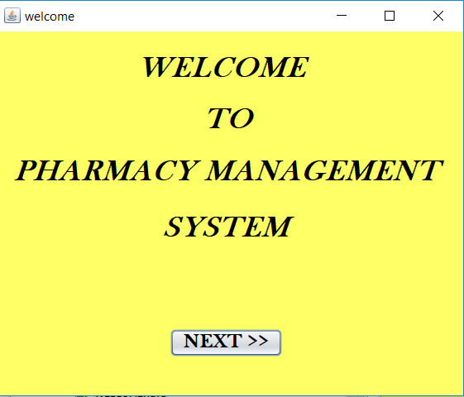

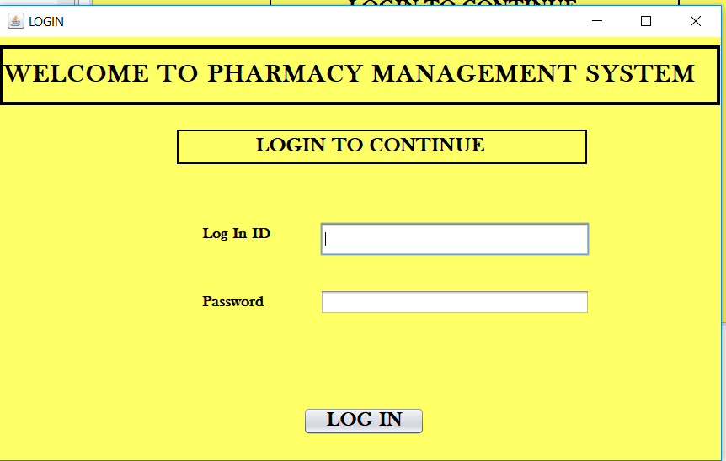



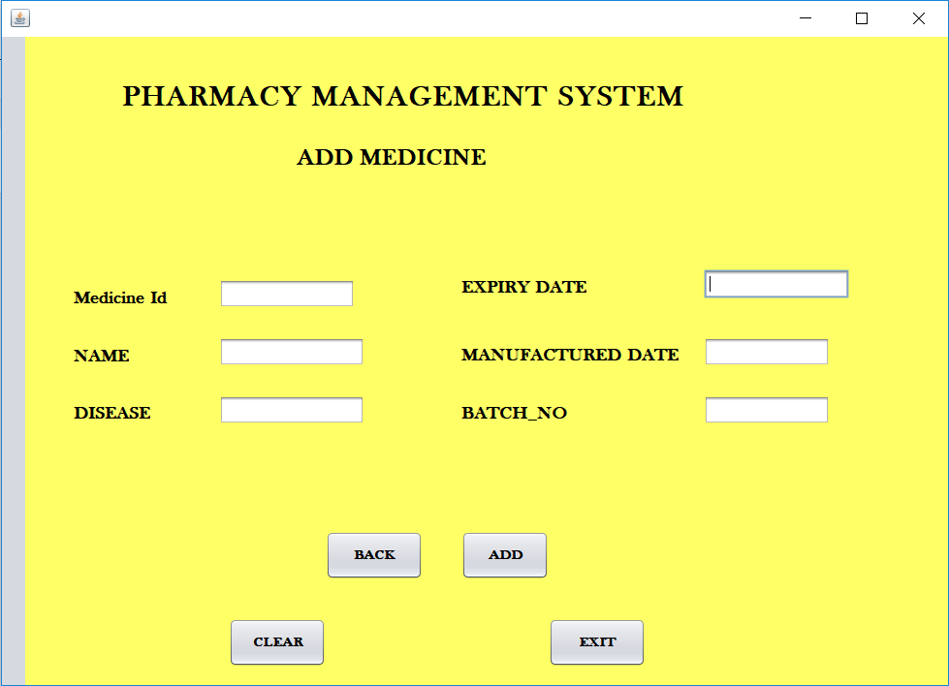

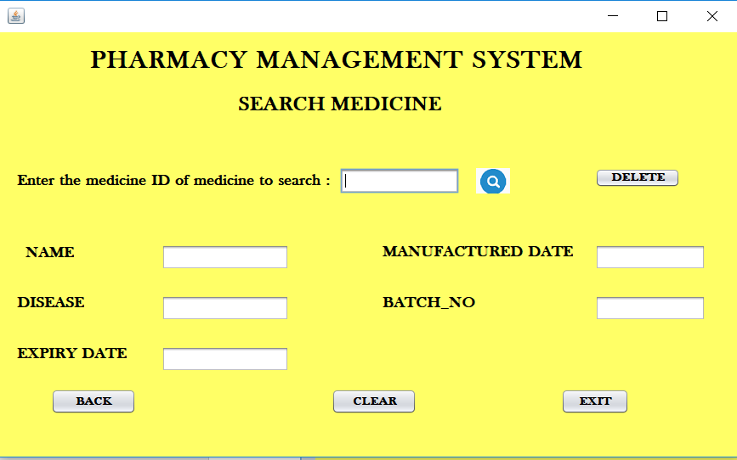

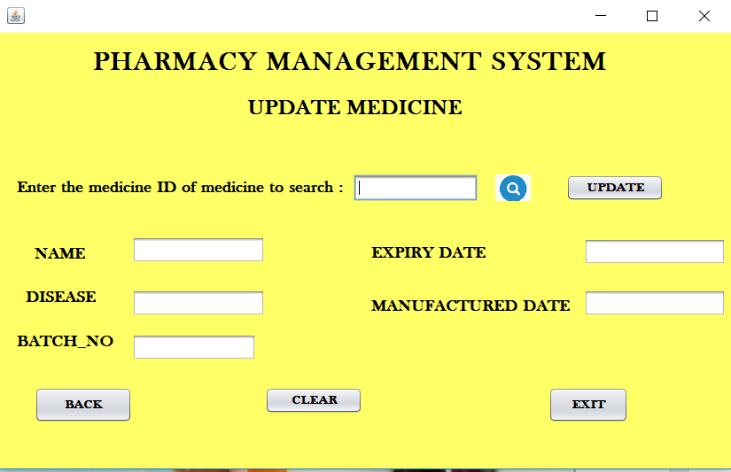

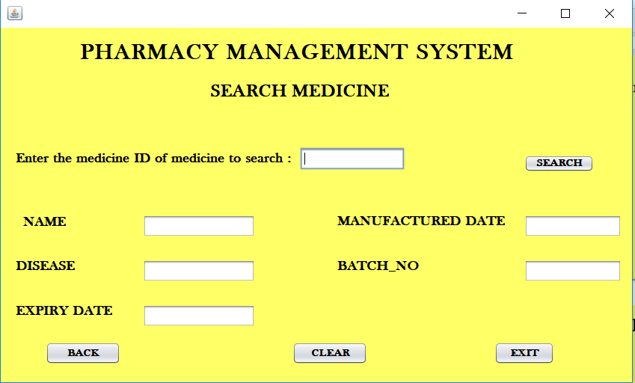

**Members Contribution**

1. Pravesh Bisaria – ER Diagram , Relational Model, Database Schema, Normalised Tables, SQL Queries, Front End
2. Viral Natani – ER Diagram, Relational Model, Database Schema, Normalised Tables
3. Hitika Alani – ER Diagram, Improved Functional Requirements, Data Dictionary, Sample Records, Back End, Front End
4. Yashi Saini – ER Diagram, Data Dictionary, Sample Records, Back End, Front End